**Electrical Cable and Junction placement JSON description:**

A JSON file is used to describe a wall and its unique features. This includes the wall contours, holes, cuts and all features to manufacture the wall. Within the file the electrical cable paths and connector locations are defined.

Format:

* *electricalCablePaths <object list>*
  + *id <string>*
  + *wireType <int>*
  + *length <float64>*
  + *segments <object list>*
    - *id <string>*
    - *line <boolean>*
    - *points <object>*
      * *x <float64>*
      * *y <float64>*
      * *type <int>*

The electricalCablePaths describes the path of the cable, describing that path's cable type, overall length, identifier within the wall and the respective segments that make up the path.

A path segment is defined by an identifier within the wall, a boolean for type of path (straight line or not straight line meaning it is an arc) as well as points related to that specific segment. For straight lines the points are first the start point followed by the end point. Arcs (where line is false) the first point is the start of the arc with the mid point along the curve being the next point and then the last point being the end of the end of the arc. The type of point describes whether that point is at the edge of the wall (1), within the wall (0) or within the wall but at a connector junction (2). The diagram below indicates a path definition with the respective JSON terms:

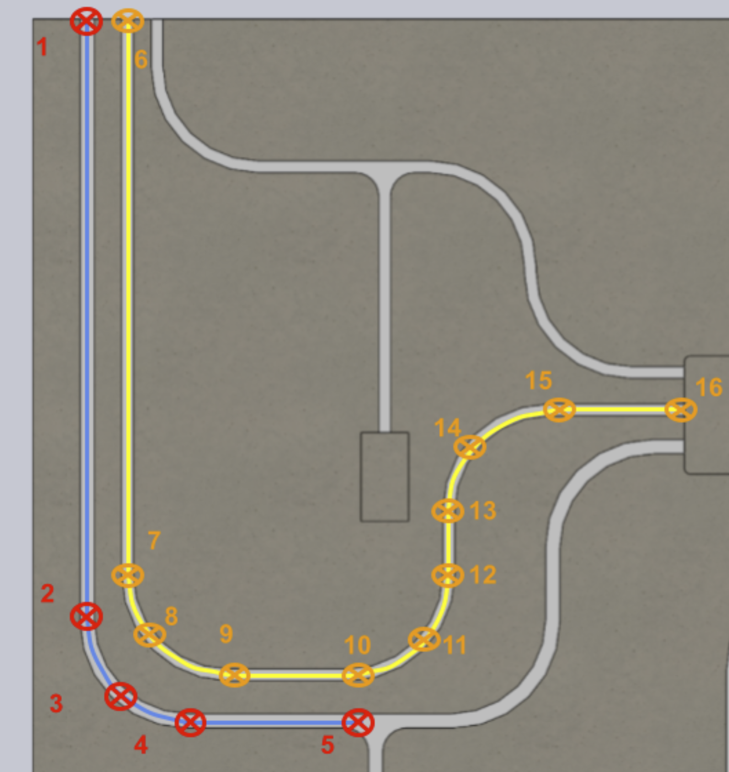

The blue path is made up of 3 different segments, the first is a straight line between points 1 and point 2, the second segment is an arc with the start being point 2, the midpoint being point 3 and the end being point 4, the third segment is a straight line between point 4 and point 5. The types of each point are below:

* Point 1: 1 (edge of wall)
* Point 2: 0
* Point 3: 0
* Point 4: 0
* Point 5: 2 (junction connector)

The yellow path is made up of 7 different segments. The summary of segments below:

* Segment 1: straight line pt 6 and 7
* Segment 2: arc pt 7, 8 and 9
* Segment 3: straight line pt 9 and 10
* Segment 4: arc pt 10, 11 and 12
* Segment 5: straight line pt 12 and 13
* Segment 6: arc pt 13, 14 and 15
* Segment 7: straight line pt 15 and 16

The point types would be

* Point 6: 1 (edge of wall)
* Point 7: 0
* Point 8: 0
* Point 9: 0
* Point 10: 0
* Point 11: 0
* Point 12: 0
* Point 13: 0
* Point 14: 0
* Point 15: 0
* Point 16: 1 (inlet to a device - edge of the wall)

Note points do not have a number or identifier and are based on their order within the point list as to what they relate to, e.g. the first point in a line is the start and second if the end. The first point in an arc is the start, the second is the midpoint and the last is the end.

The wireType definition currently is an integer enumeration for the different types of wire such that:

|  |  |
| --- | --- |
| **wireType** | **Associated Value** |
| 1 | 3 core 2.5 mm2 |
| 2 | 3 core 4 mm2 |
| 3 | 3 core 6 mm2 |
| 4 | 4 core 1.5 mm2 |
| 5 | 4 core 2.5 mm2 |

Format

* *electricalJunction <object list>*
  + *id <string>*
  + *position <object>*
    - *x <float64>*
    - *y <float64>*
  + *orientation <float64>*

The electricalJunction defines the position and orientation of the junction connectors for the wall. Each junction is defined with an identifier within the wall and x,y position with and orientation measured in degrees.

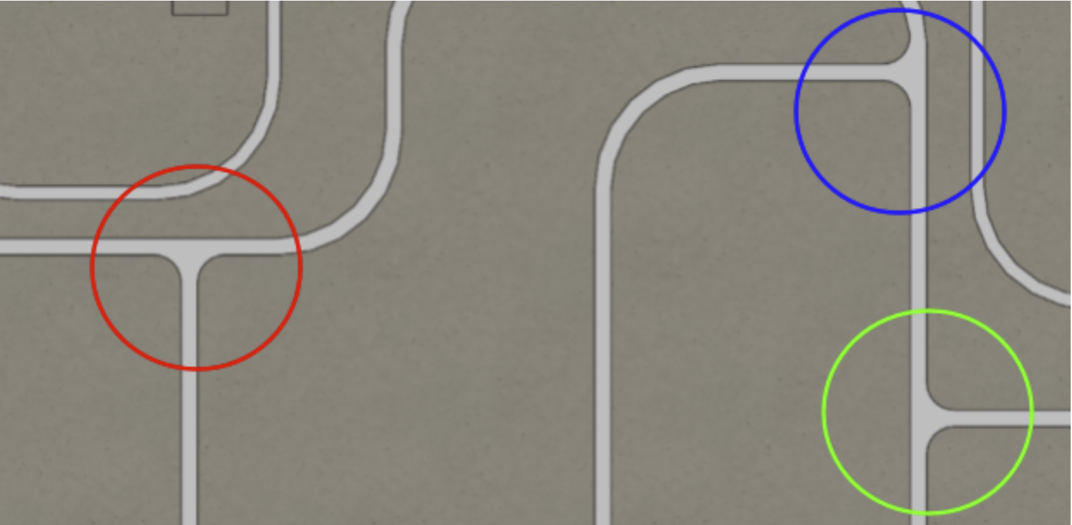

The red circle encompasses a junction with orientation of 0, the blue circle is orientation 90 and the green circle is orientation 270. This relates to a clockwise rotation with the junction in the red circle being the zero orientation.

As a summary the wall below relates to the provided example JSON file, with the paths and junctions labelled (with indicated coordinate system).